Day3 Lab Assignments

1-Complete the following in the Products component
  - Change the background color to yellow for the rows which contains product with quantity=1 and make the background color with the default color when the quantity is more than 1 [Use ngClass or ngStyle].

2-Filter products by price using nested components from parent take value of filter and in child show products after filter(parent to child )

3-Make “Product Card” custom attribute directive that makes a rounded border with shadow around the div displaying products, as the following:
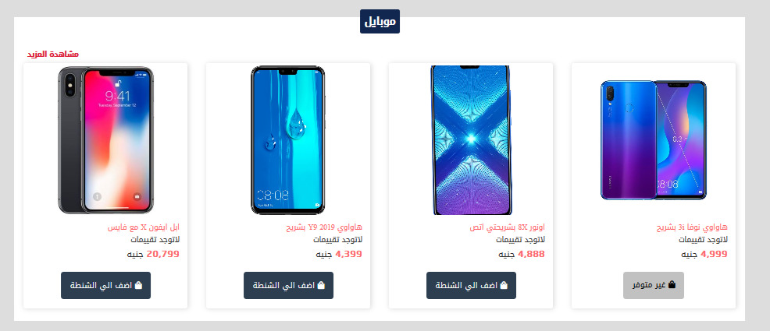
  - Use @HostListner to handle that on hover increases the shadow, and on mouse out back to the original shadow.
  - Use ngOnChanges in custom directives.

- In your Product component:
  - Add Purchase date field, and use date pipe with it to display it in suitable format.
  - Use Currency pipe with the total price field.

- Make a custom pipe, that formats the credit card number given in format like “0000000000000000” to this format “0000 – 0000 – 0000 – 0000”.

